ME300 Applied Elasticity David Wootton Cooper Union
Homework 6. Beam Bending Lab

- Complete the 3-point bending lab data sheet for your team’s experiment. (Turn in one copy per team.)
- Extend your MATLAB macro to compute axial and transverse normal stress, shear stress, principal stresses, von mises stress, and maximum shear stress, using the measured strain fields and the properties of the beam material (McMaster-Carr Aluminum 6061-T6511). Turn in contour plots for 2kN load, and your MATLAB macro code.
For plane stress:
$$σ_{xx}=\frac{E}{1-ν^{2}}\left(ε_{xx}+νε_{yy}\right)$$
$$σ_{yy}=\frac{E}{1-ν^{2}}\left(ε_{yy}+νε_{xx}\right)$$
$$τ_{xy}=Gγ_{xy}, G=\frac{E}{2(1+ν)}, γ_{xy}=2ε_{xy}$$
Principle stresses:
$$σ_{1,2}=\frac{σ_{xx}+σ_{yy}}{2}±\sqrt{{\left(\frac{σ_{xx}-σ_{yy}}{2}\right)}^{2}+τ_{xy}^{2}}$$
$$σ_{3}=0 (plane stress)$$
Max shear stress:
$$τ_{\max{,}\text{absolute}}=\frac{σ_{max}-σ_{min}}{2}$$
Where $σ_{max}, σ_{min}$ are the max and min principle stresses out of $σ_{1},σ_{2},σ_{3}$

Von mises stress:
$$σ_{VM}=\sqrt{σ_{1}^{2}-σ_{1}σ_{2}+σ_{2}^{2}}=\sqrt{σ_{xx}^{2}-σ_{xx}σ_{yy}+σ_{yy}^{2}+3τ_{xy}^{2}}$$
Material properties for Alloy 6061-T6
$$E=70 GPa, G=26 GPa$$
$$ν=\frac{E}{2G}-1=0.346$$
Yield strength of Alloy 6061 T6511: 35,000 psi
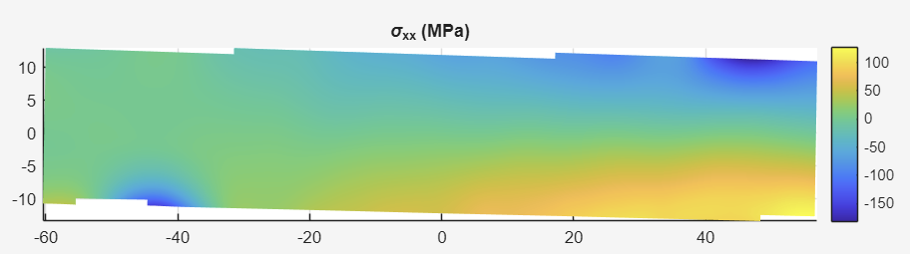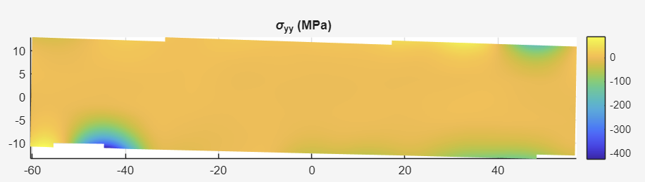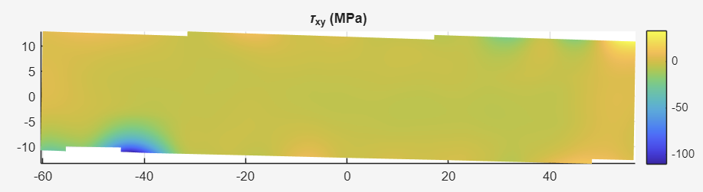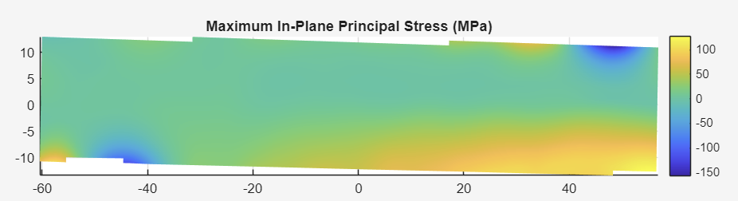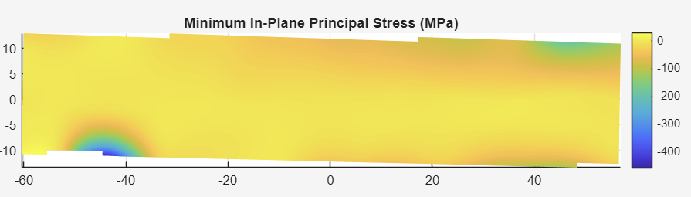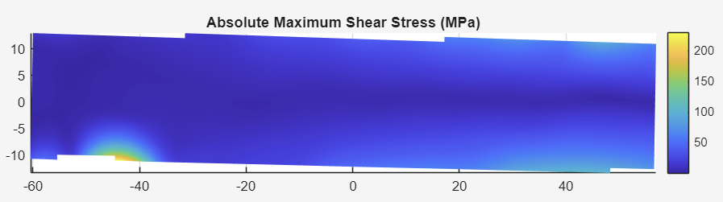
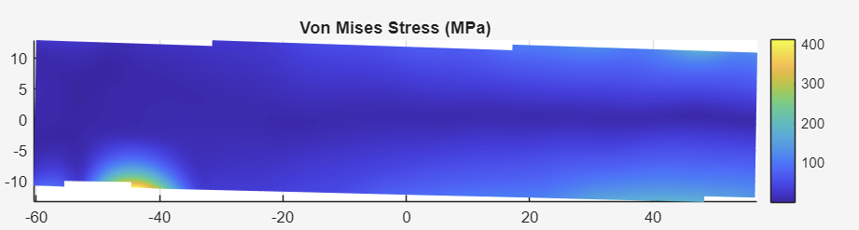
- Do you see any evidence that your beam sample yielded? Explain.
- Residual displacement after unloading was -0.0333974 mm, which may be significant if it is much greater than the uncertainty range of the DIC. If so, then this could indicate yielding. From the contour plot, most of the transverse displacement is in the region surrounding the load point.
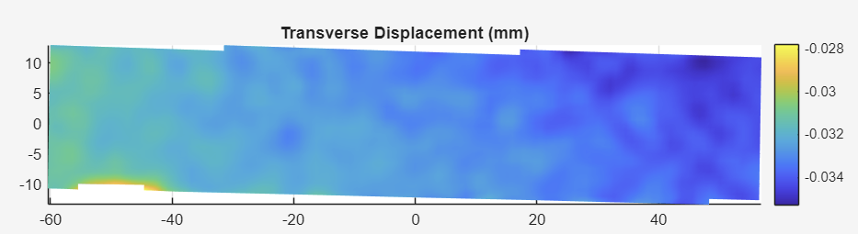
- Additionally, there was residual strain left over:

The residual axial strain appears to be dominated by measurement noise rather than a clear pattern of permanent mechanical strain within the beam.
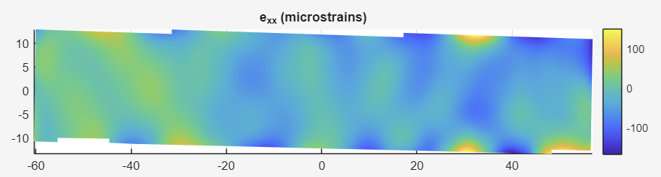
The residual transverse strain appears to be more concentrated around the support point on the bottom left of the beam.
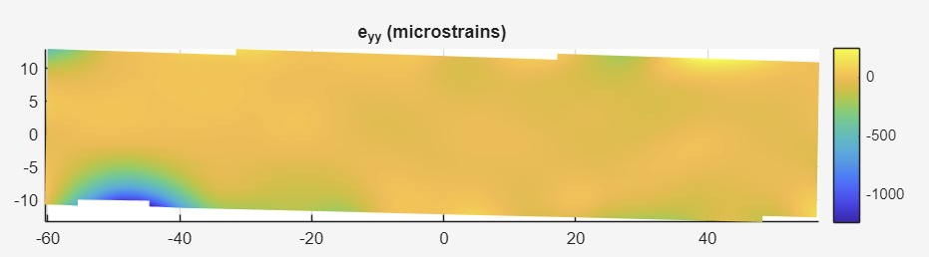
Like the residual axial strain, the strain pattern appears to be less obvious which correlates to noise strongly.
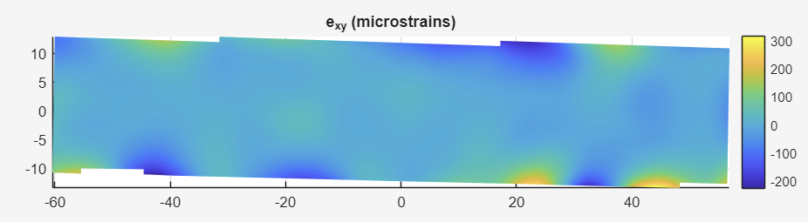
- Comparing the von Mises stress to the yield strength of the material, the maximum von Mises stress under the 2 kN load was significantly greater than the yield strength. However, it is worth noting that this was a highly localized stress concentration rather than a more widely distributed stress field, making it difficult to conclusively determine whether yielding occurred beyond the localized region.
- We can also compare the linearity of the stress vs strain curves of the material. In the linear elastic region for isotropic materials, there should be strong linear trends.

